**Mahendra Institute Of Technology(Autonomous)**

**Ideation Phase**

**Define the Problem Statements**

|  |  |
| --- | --- |
| Date | 30 SEPTEMBER 2022 |
| Team ID | PNT2022TMID17271 |
| Project Name | AI Based A Noval Method For Handwritten  Digit Recognition System |
| Maximum Marks | 2 Mark |

**Customer Problem Statement Template:**

Handwriting Recognition has an active community of academics studying it. The biggest conferences for handwriting recognition are the International Conference on Frontiers in Handwriting Recognition (ICFHR), held in even-numbered years, and the International Conference on Document Analysis and Recognition (ICDAR), held in odd-numbered years. Both of these conferences are endorsed by the IEEE.

Reference: <https://miro.com/templates/customer-problem-statement/>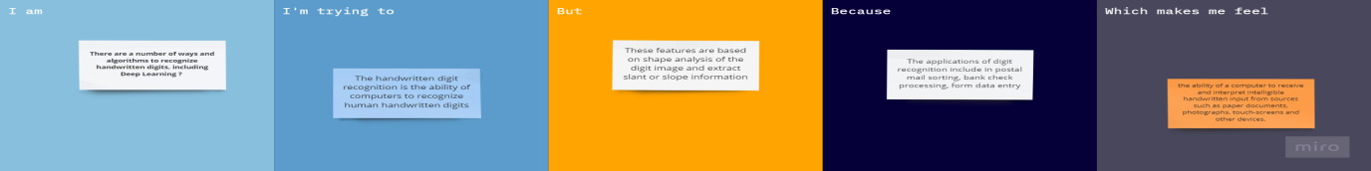

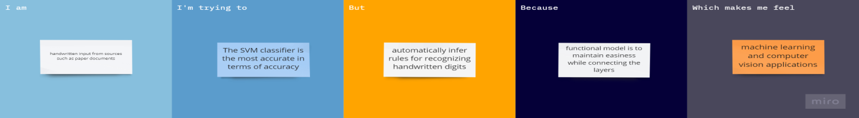

|  |  |  |  |  |  |
| --- | --- | --- | --- | --- | --- |
| **Problem Statement (PS)** | **Iam (Customer)** | **I’m trying to** | **But** | **Because** | **Which makes me feel** |
| PS-1 | Handwritten  input from  sources such as paper  documents | The SVM classifier is the most accurate in terms of accuracy | automatically infer rules for recognizing handwritten digits | functional model is to maintain easiness while connecting the layers | machine learning and computer vision applications |
| PS-2 | There are a number of ways and algorithms to recognize handwritten digitsg | The handwritten digit recognition is the ability of computers | These features are based on shape analysis of the digit image | The applications of digit recognition include in postal mail sorting, | ability of a computer to receive and interpret intelligible handwritten input from sources |